Identifying Energy Forms and Transformations 11/14
TOC #4

Integrated Science 3 Name: Per:
The following activities are designed to provide practice identifying the various forms of energy and processes that transform one form of energy into another.

Part I: Energy Form Card Sort
Procedures: You have been provided with a stack of cards with pictures of various things that have energy. You will sort the cards into particular groups. Each group of cards must contain more than one card, and all of the cards must be used. Work with your group to come up with the reason(s) you placed a card in a particular group. Be able to explain your reasons to your classmates.

- Sort the cards into two groups: potential and kinetic energy. Record the way you sorted the cards by writing the name of the cards in the table below:

Potential Energy | Kinetic Energy

- Sort the cards into the seven different energy types. Use the definitions below to help guide your card sort. Record the way you sorted the cards by writing the name of the cards in the table below:
- Mechanical (movement) Energy- related to the movement of objects or its position in gravity
- Sound Energy- relates to the vibrations of matter
- Chemical Energy- related to the potential energy stored in the bonds between atoms in a compound
- Radiant (light) Energy- related to the electromagnetic waves that can travel through a vacuum such as space
- Electrical Energy- related to the movement or flow of electrons which carry a charge
- Heat (thermal) Energy- related to the motions of atoms or molecules in a substance
- Nuclear Energy- related to the potential energy stored in bonds between particles in the nucleus of an atom

Mechanical | Sound | Chemical | Light | Electrical | Heat | Nuclear

Part II: Energy Transformation
Procedures: In each of the empty boxes below, write the number of the device (provided in Table 2.) that could convert energy from the form listed on the left side to the form named at the top. Refer to the light bulb example that has been done for you. Place only one number in a box. Numbers are only used once.

Data Table 1. Energy Transformation Chart
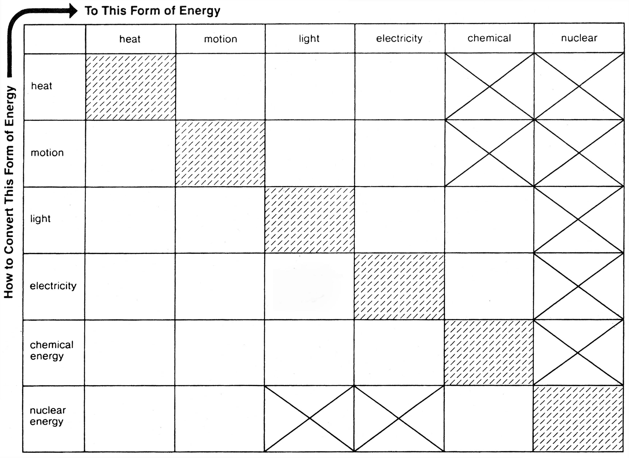
A

Example:
A. 
light bulb

Data Table 2. Devices and Processes
